Devops Practical

1. Perform GIT operations on local remote repositories. (Create Repository, add files. Commit changes, pushing objects to remote repository)

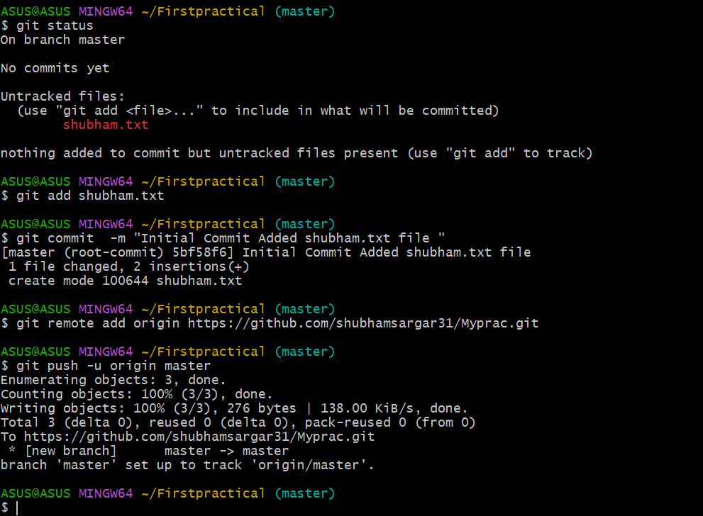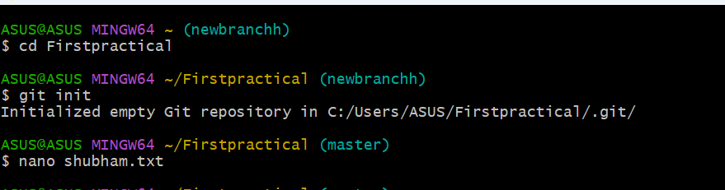

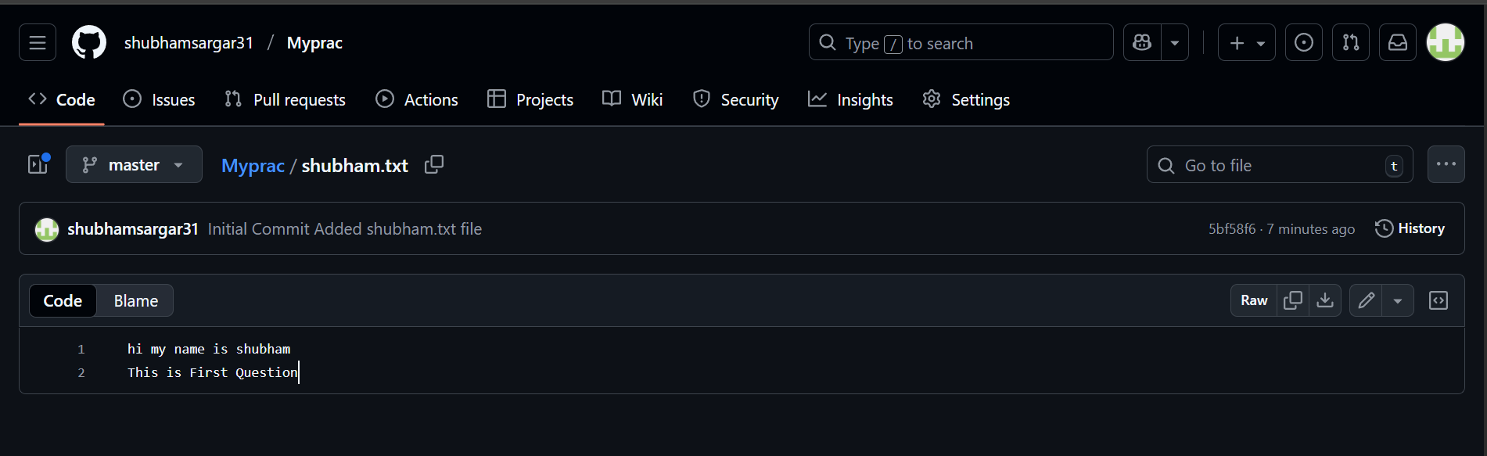

1. Perform GIT operations on local remote repositories.(Create Repository, add files, create branches, switch between branches)

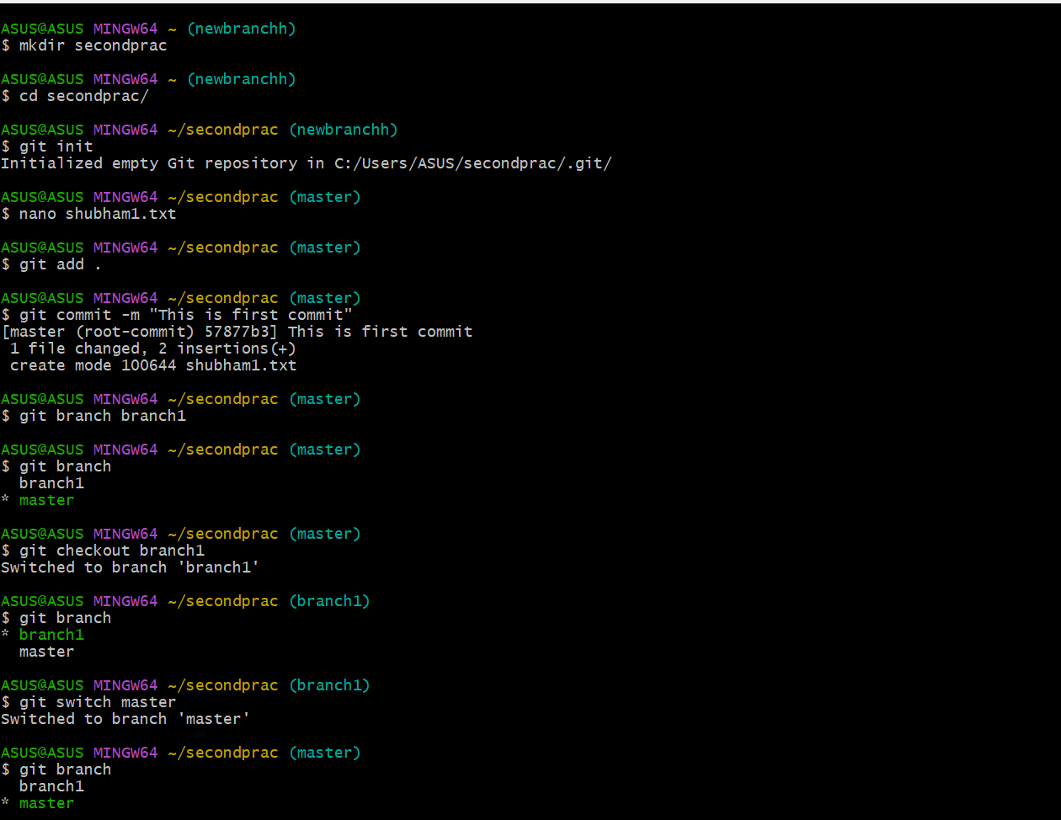

1. Perform GIT operations on Remote repositories (Create Repository, add files. Commit changes, cloning, pulling and pushing objects)

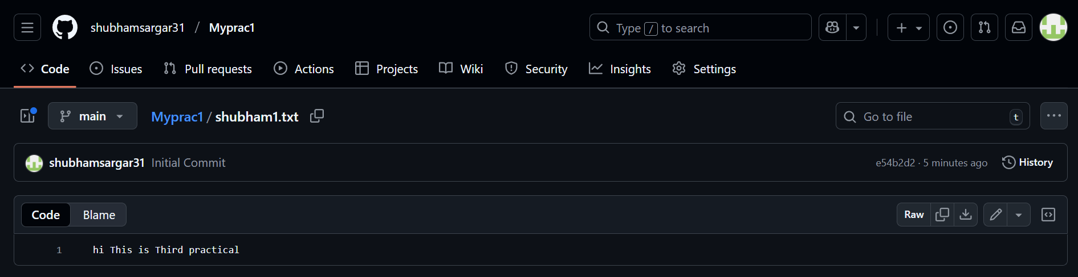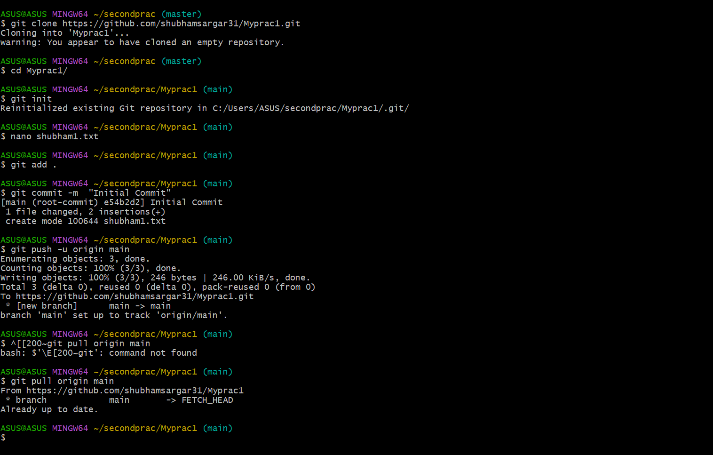

1. Build the Java jobs using in Jenkins

**Build the Java Job using Jenkins**

**Step 1:**  
Create a Java file → sample.java

public class sample {

public static void main(String[] args) {

System.out.println("Hello Java in Jenkins!");

}

}

**Step 2:**  
Open Jenkins → http://localhost:8080/

**Step 3:**  
**New Item → Freestyle Project** → give name: JavaJob

**Step 4:**  
Go to **Build → Add build step → Execute Windows batch command**  
Type:

javac sample.java

java sample

**Step 5:**  
Click **Save → Build Now**

**Step 6:**  
Check **Console Output** → you should see:

Hello Java in Jenkins!

1. Build the python jobs using in Jenkins

**Step 1:**  
Create Python file → sample.py

print("Hello Python in Jenkins!")

**Step 2:**  
**New Item → Freestyle Project** → give name: PythonJob

**Step 3:**  
Go to **Build → Add build step → Execute Windows batch command**  
Type:

python sample.py

**Step 4:**  
Click **Save → Build Now**

**Step 5:**  
Check **Console Output** → you should see:

Hello Python in Jenkins!

1. **Crete a simple pipeline script using Jenkins**

**Step 1:**  
**New Item → Pipeline** → give name: SimplePipeline

**Step 2:**  
In **Pipeline Script** section, paste:

pipeline {

agent any

stages {

stage(“git check”){

steps{

git branch : ‘main’ <url:”git> url”

}

}

stage('Build Java') {

steps {

script {

if (fileExists('sample.java')) {

bat 'javac sample.java'

bat 'java sample'

} else {

echo 'No Java file found.'

}

}

}

}

stage('Run Python') {

steps {

script {

if (fileExists('sample.py')) {

bat 'python sample.py'

} else {

echo 'No Python file found.'

}

}

}

}

}

post {

success {

echo 'Pipeline completed successfully!'

}

failure {

echo 'Pipeline failed. Check errors above.'

}

}

}

**Step 3:**  
Click **Save → Build Now**

**Step 4:**  
Check **Console Output** → output from both Java and Python programs will appear (if files exist).

Question 7 Docker

docker version

docker info

docker images

docker image ls

docker ps

docker ps -a

docker pull ubuntu

docker inspect ubuntu

docker rmi ubuntu